**Optical Gyro:**

When the light is emitted from the start and the circular tube is rotated in clockwise direction then the ray at the right reach the end fast than the left ray of light which is called **Signac** **Effect**. In real life, there is a slight difference in time of arrival so can’t be measured directly however we an measure a frequency shift between the two beams.

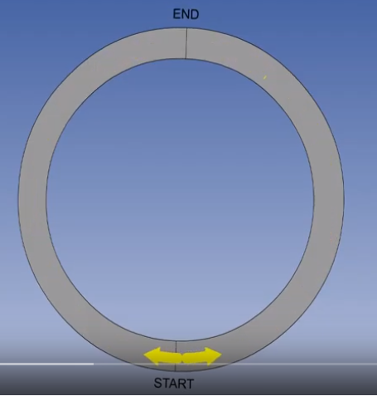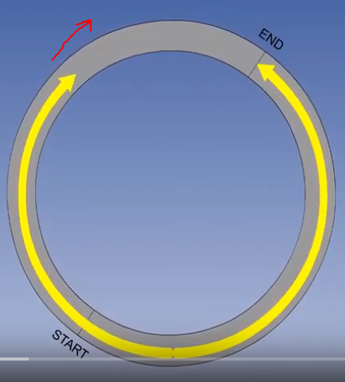

In practice it is difficult to make light travel on a circular path but same effect can be achieved by light paths reflected by mirrors into a triangular pattern.

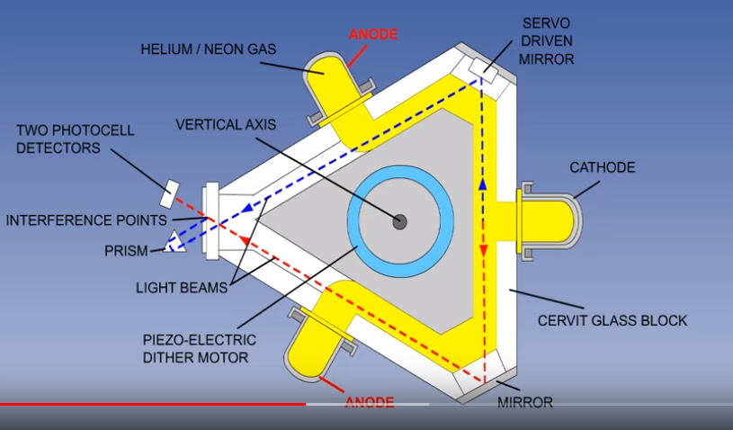

The right laser gyro uses the Signa effect, it is basically a triangular glass prism containing drilled tubular cavities. Consists cathode (emits photons), 2 anodes (opposite electrical polarity to cathode). Large potential difference (same in both anode) is maintained between them which causes photos to be powerfully attracted towards the anode. Light divides approximately in two half, moving in clockwise and anti-clockwise direction. Drilled tubular cavity filled with helium and neon gas (acts as conducting medium). Laser produced is coherent light (frequency same).

If the prism rotates about its sensitive axis, the number of wavelengths in each path length remains same but the path length change. This means frequency must change. Conversion of frequency change into a measure of angular rotation rate is achieved by interference pattern technology. Inteference pattern is formed when two beams of light converge on a single point. Two peaks meet, intensity increases and ‘peak and crest’ meet intensity decreases. On the screen, patter is seen as below.





With two light sources at the same frequency in phase, the pattern remains static but if the frequencies altern the pattern moves. The direction and rate of pattern movement are a measure of aircraft’s rotation direction and rate.

The laser gyro contains a photoelectric detector and it can tell if the interference pattern is static or it is moving. It can detect the direction and rate of rotation.

Piezo electric dinner motor therefore provides a constant input of vibration at a known frequency which prevent laser lock (condition where two light synchronize output is zero, through there is rotation). The effect of this vibration is removed from the laser gyro output which is the desired measure of angular rotation.

**Laser gyro are fixed to airframe called strapped down system. Uses principle of Signac effect to measure the angular rotation rate in pitch roll and yaw.**

**Accelerometers:**

The acceleration of a vehicle can be determined by measuring the force required to

constrain a suspended mass so that it has the same acceleration as the vehicle on

which it is suspended, using Newton’s law: force = mass × acceleration.

The measurement is complicated by the fundamental fact that it is impossible

to distinguish between the force acting on the suspended mass due to the Earth’s

gravitational attraction and the force required to overcome the inertia and accelerate

the mass so that it has the same acceleration as the vehicle. The vehicle acceleration,

**a**, being produced by the vector sum of the external forces acting on the vehicle,

namely, the propulsive thrust, **T**, lift, **L**, drag, **D**, and the gravitational force, *m***g**,

acting on the aircraft mass, *m*.

(The bold print denote the quantities are vector quantities.)

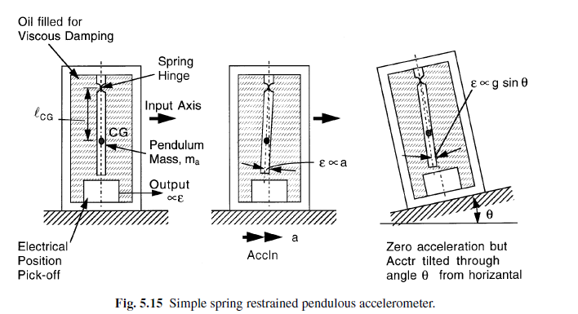**T** + **L** + **D** + *m***g** = *m***a**

**a** = *(***T** + **L** + **D***)/m*+ **g** (5.13)

The vector sum of the external forces excluding the gravitational force divided

by the aircraft mass, that is *(***T** + **L** + **D***)/m*, is known as the ‘specific force’. The

force, **Fa**, required to constrain the suspended mass, *ma*, is thus given by

Inertial force required to oppose the inertia created by (external force+gravity)= total acceleration produced on boy

**(Fa)** + (*ma)***g** = (*ma)***a**

**Inertia force acting on body equals to accelerating external force**

**(Fa)/(***ma)*+ **g** = **a** = *(***T** + **L** + **D***)***/***m*+ **g**

Hence,

**(Fa)** = *ma*(***T** + **L** + **D***)/m* (5.14)

**Definition of inertial force: A FORCE OPPOSITE IN DIRECTION TO AN ACCELERATING FORCE acting on a body and EQUAL TO THE PRODUCT OF THE ACCELERATING FORCE AND THE MASS OF THE BODY.**

i.e. the accelerometer will thus measure the specific force component along its input

axis and *not* the vehicle acceleration component.

It is thus essential to know the magnitude and orientation of the gravitational

vector with respect to the accelerometer input axes in order to compute the vehicle

acceleration components from the accelerometer outputs.

Only if the accelerometer input axis is exactly orthogonal to the gravity vector (ie

horizontal) so that there is zero gravitational force component will the accelerometer

measure the vehicle acceleration component along its input axis.

**Euler angles** The aircraft attitude is defined by a set of three ordered rotations,

known as the Euler angles, from a fixed reference axis frame; the aircraft is assumed

to be initially aligned with the reference axes:

1. A clockwise rotation in the horizontal plane through the *yaw angle* about the

yaw (or vertical) axis.

2. A clockwise rotation through the *pitch angle* about the pitch (or side-slip)

axis.

3. A clockwise rotation through the *bank angle* about the roll (or forward) axis.

**CHAPTER 6**

**Instrument Error**  
Inaccuracies in the construction, friction and play in the moving parts produces instrument error.  
The effect of changes in temperature extending and contracting the linkages is countered by including a bi-metallic strip that distorts to correct the expansion.

* The pitot-static systems in modern aircraft are reliable, that we are always taught to "believe our instruments"
  + However, when they do fail, the failure may be so **insidious** (proceeding in a gradual, subtle way, but with very harmful effects) that it goes unnoticed until it's too late
* Pitot-static failures typically come in three varieties:
  + Icing over the Pitot or static ports
  + Trapped water in the lines (usually after Maintenance fails to cover the ports during a wash)
  + Compromise of system integrity:
    - Leaks due to holes or loose fittings
    - Kinks (a sharp twist or curve in something that is otherwise straight) in the lines
    - Obstructions/blockages
    - Taped or covered ports
* Blockages in the system can cause a variety of errors
* To prevent these errors, you must complete a thorough pre-flight
* Blockages can occur from striking an object (damaging instruments), insects, trapped moisture, loss of system integrity, icing, etc.

**Position Error:**

* Air at the static system entrance (static pressure area also consists certain dynamic pressure) not being absolutely still.
* The Pitot tube is aligned with the direction of flight and usually mounted on the leading edge of the wing of the aircraft. The static port is placed in an area of relatively undisturbed air flow such as on the side of the fuselage. The amount of position error changes with the angle of attack or airspeed of the aircraft and is usually greatest at low airspeeds when the angle of attack is the highest (as pitot tube is not parallel to wind direction)

**Airspeed:**

**Airspeed** is the [speed](https://en.wikipedia.org/wiki/Speed) of an [aircraft](https://en.wikipedia.org/wiki/Aircraft) relative to the [air](https://en.wikipedia.org/wiki/Air). Among the common conventions for qualifying airspeed are indicated airspeed ("IAS"), calibrated airspeed ("CAS"), equivalent airspeed ("EAS"), true airspeed ("TAS"), and density airspeed.

**Airspeed indicator:**

**Airspeed indicator**, instrument that measures the speed of an aircraft relative to the surrounding air, using the differential between the pressure of still air (static pressure) and that of moving air compressed by the craft’s forward motion (ram pressure); as speed increases, the difference between these pressures increases as well.

Pressures are measured by a [**Pitot tube**](https://www.britannica.com/technology/pitot-tube), a U-shaped apparatus with two openings, one perpendicular to the flow of air past the aircraft (static) and one facing directly into the flow. Mercury or a similar liquid fills the bend in the tube, forming parallel columns balanced by the air pressure on each side. When static and ram pressure are equal, the columns have the same height. As the ram pressure increases, mercury on that side of the tube is pushed back and the columns become imbalanced. The difference between the two columns can be [calibrated](https://www.merriam-webster.com/dictionary/calibrated) to indicate the speed; this value, called the indicated airspeed, may be given in knots, miles per [hour](https://www.britannica.com/science/hour), or other units.

**Since the airspeed indicator is calibrated at standard temperature and pressure, its readings are inaccurate at different temperatures and altitudes**. An (uncorrected) indicated airspeed is still used to estimate an aircraft’s tendency to stall. **Instruments that electronically correct for altitudinal differences and temperature give the true airspeed, which is used to calculate the aircraft’s position.** In faster aircraft, indicators that measure airspeed relative to the [speed of sound](https://www.britannica.com/science/speed-of-sound-physics), called [Mach meters](https://www.britannica.com/technology/Machmeter), are used.

**Types of Airspeeds:**

Aircrew are primarily concerned with Indicated Airspeed and True Airspeed in flight with regards to performance

* **Indicated Airspeed (IAS):**
  + The IAS is the direct airspeed reading shown by an airspeed indicator
  + The reading has not been corrected for variations in atmospheric density, installation error, or instrument errors
  + As height increases, the indicated airspeed falls below the true airspeed (as the density decreases with height so the collisions)
  + Manufacturers use this airspeed as the basis for determining aircraft performance
  + IAS will **not** normally vary with altitude or temperature and so your V-speeds listed in the AFM/POH will mostly vary due to weight
* **Calibrated Airspeed (CAS):**
  + CAS is the indicated airspeed of an aircraft, corrected for position and instrument error
    - Errors can include angle of attack (pitot tube present in wing not being parallel), flap configuration, ground proximity, wind direction, to name a few
    - Errors can sometimes equal several knots and are **generally greatest at low airspeeds (as AOA is high)**
  + Any errors that interfere with the system reading total and static pressure (which when subtracted give you dynamic pressure) are corrected here
  + This will give the actual speed in which aircraft is moving through the air
  + Calibrated airspeed is equal to true airspeed in standard atmosphere at sea level (High AoA, minimal error at cruise)
  + The POH/AFM has a chart or graph to correct IAS for these errors and provide the correct CAS for the various flap and landing gear configurations [***Figure 5***]
  + Note that some aircraft have alternate static sources which may need to be referenced in a separate chart
* **Equivalent Airspeed (EAS):**
  + Equivalent airspeed is more designed for engineers and not usually practical for pilots
  + The airspeed corrected for compressibility effects above 180-200 knots and 20,000', which is the airspeed the airplane "feels". (Very high speed, shockwave formed so the air is compressed in much amount)
  + As the airspeed and pressure altitude increase, the CAS becomes higher than it should be as air molecules begin to stack up against the aircraft and instruments
  + A correction for compression must be subtracted from the CAS
* **True Airspeed (TAS):**
  + Because the **Pitot-system does not detect air density changes**, it is calibrated to standard sea level pressure and any changes in pressure (or altitude**) thereby requires a correction**
  + Further, as air density decreases with an increase in altitude, an aircraft has to be flown faster at higher altitudes (to maintain level flight) to cause the same pressure difference between pitot impact pressure and static pressure
    - Therefore, for a given CAS, TAS increases as altitude increases; or for a given TAS, CAS decreases as altitude increases
  + **TAS is therefore CAS corrected for non-standard temperature, with the help of an Outside Air Temperature (OAT) gauge, and altitude**
  + The TAS is the speed that is used for flight planning and is used when filing a flight plan
  + On higher performance aircraft, a true airspeed indicator may be installed
  + **Calculating True Airspeed:**
    - **Flight Computer Method:**
      * The most accurate method is to use a flight computer
      * With this method, the CAS is corrected for temperature and pressure variation by using the airspeed correction scale on the computer
      * Extremely accurate electronic flight computers are also available
        + Just enter the CAS, pressure altitude, and temperature, and the computer calculates the TAS
    - **Rule of Thumb:**
      * A second method, which is a rule of thumb, provides the approximate TAS
      * Simply add 2 percent to the CAS for each 1,000 feet of altitude
      * **Formula:**
        + 5 (5000 ft) * 0.02 = .1 (correction factor)
        + .1 * 100 KCAS (cruise airspeed) = 10 knots (correction speed)
        + 100 (CAS) + 10 = 110 knots TAS
* **Ground Speed (GS):**
  + Groundspeed (GS) is the actual speed of the airplane over the ground
  + It is TAS adjusted for wind (airmass movement)
  + GS decreases with a headwind and increases with a tailwind
  + Ground Speed is a primary concern for performance during cross-country planning



**Airspeed Conversions**

**True Air-speed:**

It’s the aircraft speed relative to the air in which it’s flying**. Airspeed indicator doesn’t measure speed, it measures pressure.** Airspeed indicator reads accurately at sea level in standard conditions but as you start to climb, pressure then they become non-standard and temperature goes on changing and your airspeed indicator doesn’t report accurate speed. That’s because your airspeed indicator reports a **slower speed than true airspeed** as density is decreased.

With EAS constant, true airspeed increases as aircraft [altitude](https://en.wikipedia.org/wiki/Altitude) increases. This is because [air density](https://en.wikipedia.org/wiki/Air_density) decreases with higher altitude, but an aircraft's wing requires the same amount of air particles (i.e., [mass of air](https://en.wikipedia.org/wiki/Air_mass)) flowing around it to produce the same amount of lift for a given AOA; thus, a wing must move faster through thinner air than thicker air to obtain the same amount of lift.

The **true airspeed** (**TAS**; also **KTAS**, for *knots true airspeed*) of an aircraft is the speed of the aircraft relative to the airmass in which it is flying.

TAS is the true measure of aircraft performance in cruise, thus it is the speed listed in aircraft specifications, manuals, performance comparisons, pilot reports, and every situation when cruise or endurance performance needs to be measured. It is the speed normally listed on the flight plan, also used in [flight planning](https://en.wikipedia.org/wiki/Flight_planning), before considering the effects of wind.

True airspeed is related to the [Mach number](https://en.wikipedia.org/wiki/Mach_number) {\displaystyle M} and [speed of sound](https://en.wikipedia.org/wiki/Speed_of_sound) {\displaystyle c} by

TAS=M*c

{\displaystyle \mathrm {TAS} =cM}

**Indicated airspeed:**

[Indicated airspeed](https://en.wikipedia.org/wiki/Indicated_airspeed) (IAS) is the [airspeed indicator](https://en.wikipedia.org/wiki/Airspeed_indicator) reading (ASIR) uncorrected for instrument, position, and other errors. From current EASA definitions: Indicated airspeed means the speed of an aircraft as shown on its pitot static airspeed indicator calibrated to reflect standard atmosphere adiabatic compressible flow at sea level uncorrected for airspeed system errors.[[3]](https://en.wikipedia.org/wiki/Airspeed#cite_note-3)

**Calibrated airspeed:**

Calibrated airspeed (CAS) is indicated airspeed corrected for instrument errors, position error (due to incorrect pressure at the static port) and installation errors.

**Ground Speed:**

**Ground speed** is the horizontal speed of an [aircraft](https://en.wikipedia.org/wiki/Aircraft) relative to the ground.[[1]](https://en.wikipedia.org/wiki/Ground_speed#cite_note-1) An aircraft heading vertically would have a ground speed of zero.

Ground speed can be determined by the [vector sum](https://en.wikipedia.org/wiki/Vector_sum) of the aircraft's [true airspeed](https://en.wikipedia.org/wiki/True_airspeed) and the current wind speed and direction; a [headwind](https://en.wikipedia.org/wiki/Headwind) subtracts from the ground speed, while a [tailwind](https://en.wikipedia.org/wiki/Tailwind) adds to it. Winds at other angles to the heading will have components of either headwind or tailwind as well as a [crosswind](https://en.wikipedia.org/wiki/Crosswind) component.

Ground speed is quite different from [airspeed](https://en.wikipedia.org/wiki/Airspeed). When an aircraft is airborne the ground speed does not determine when the aircraft will stall, and it doesn't influence the aircraft performance such as [rate of climb](https://en.wikipedia.org/wiki/Rate_of_climb).

**Ground Waves:**

The ground wave is actually composed of two separate component waves. These are known as the SURFACE WAVE and the [SPACE WAVE](http://electriciantraining.tpub.com/14182/css/Space-Wave-77.htm) (fig. 2-11). The determining factor in whether a ground wave component is classified as a [space wave](http://electriciantraining.tpub.com/14182/css/Space-Wave-77.htm) or a surface wave is simple. A surface wave travels along the surface of the Earth. A space wave travels over the surface.

**SURFACE WAVE**.—The surface wave reaches the receiving site by traveling along the surface oft he ground as shown in figure 2-12. A surface wave can follow the contours of the Earth because of the process of [diffraction](http://meteorologytraining.tpub.com/14271/css/14271_66.htm). When a surface wave meets an object and the dimensions of the object do not exceed its [wavelength](http://electriciantraining.tpub.com/14184/css/Wavelength-20.htm), the wave tends to curve or bend around the object. The smaller the object, the more pronounced the diffractive action will be.

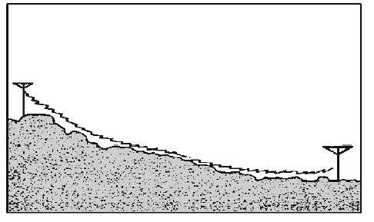

As a surface wave passes over the ground, the wave induces a voltage in the Earth. The induced voltage takes energy away from the surface wave, thereby weakening, or attenuating, the wave as it moves away from the transmitting [antenna](http://electriciantraining.tpub.com/14182/css/Chapter-4-Antennas-167.htm). To reduce the attenuation, the amount of induced voltage must be reduced. This is done by using [vertically polarized](http://electriciantraining.tpub.com/14182/css/Vertically-Polarized-99.htm) waves that minimize the extent to which the [electric field](http://armyengineer.tpub.com/TC-9-64/TC-9-640046.htm) of the wave is in contact with the Earth. When a surface wave is horizontally polarized, the [electric field](http://armyengineer.tpub.com/TC-9-64/TC-9-640046.htm) of the wave is parallel with the surface of the Earth and, therefore, is constantly in contact with it. The wave is then completely attenuated within a short distance from the transmitting site. On the other hand, when the surface wave is [vertically polarized](http://electriciantraining.tpub.com/14182/css/Vertically-Polarized-99.htm), the electric field is vertical to the Earth and merely dips into and out of the Earth's surface. For this reason, vertical [polarization](http://electriciantraining.tpub.com/14182/css/Polarization-70.htm) is vastly superior to horizontal polarization for surface [wave propagation](http://electriciantraining.tpub.com/14182/css/Chapter-1-Wave-Propagation-13.htm).

The attenuation that a surface wave undergoes because of induced voltage also depends on the electrical properties of the terrain over which the wave travels. The best type of surface is one that has good electrical [conductivity](http://nuclearpowertraining.tpub.com/h1015v2/css/Conductivity-37.htm). The better the conductivity, the less the [attenuation](http://armycommunications.tpub.com/SS0330/Attenuation-129.htm). Table 2-2 gives the relative [conductivity](http://nuclearpowertraining.tpub.com/h1015v2/css/Conductivity-37.htm) of various surfaces of the Earth.

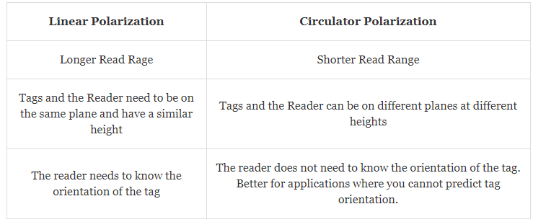

Circular polarization

Circular polarization is most often use on satellites. The polarization of the signals is rotating.  Due the position of the Earth with respect to the satellite, geometric differences may vary. Circular polarization will keep the signal constant regardless of anomalies.

**Advantages of Circular Polarization:** <https://cdn.thomasnet.com/ccp/10014548/223252.pdf>

* **Reflectivity**: Radio signals are reflected or absorbed depending on the material they come in contact with. Because linear polarized antennas are able to “attack" the problem in only one plane, if the reflecting surface does not reflect the signal precisely in the same plane, that signal strength will be lost. Since circular polarized antennas send and receive in all planes, the signal strength is not lost, but is transferred to a different plane and are still utilized.
* **Absorption**: As stated above, radio signal can be absorbed depending on the material they come in contact with. Different materials absorb the signal from different planes. As a result, circular polarized antennas give you a higher probability of a successful link because it is transmitting on all planes.
* **Phasing Issues:** High-frequency systems (i.e. 2.4 GHz and higher) that use linear polarization typically require a clear line-ofsight path between the two points in order to operate effectively. Such systems have difficulty penetrating obstructions due to reflected signals, which weaken the propagating signal. Reflected linear signals return to the propagating antenna in the opposite phase, thereby weakening the propagating signal. Conversely, circularly-polarized systems also incur reflected signals, but the reflected signal is returned in the opposite orientation, largely avoiding conflict with the propagating signal. The result is that circularly-polarized signals are much better at penetrating and bending around obstructions.
* **Multi-path:** Multi-path is caused when the primary signal and the reflected signal reach a receiver at nearly the same time. This creates an "out of phase" problem. The receiving radio must spend its resources to distinguish, sort out, and process the proper signal, thus degrading performance and speed. Linear Polarized antennas are more susceptible to multi-path due to increased possibility of reflection. Out of phase radios can cause dead-spots, decreased throughput, distance issues and reduce overall performance in a 2.4 GHz system.
* **Inclement Weather:** Rain and snow cause a microcosm of conditions explained above (i.e. reflectivity, absorption, phasing, multi-path and line of sight) Circular polarization is more resistant to signal degradation due to inclement weather conditions for all the reason stated above.
* **Line-of-Sight:** When a line-of-sight path is impaired by light obstructions (i.e. foliage or small buildings), circular polarization is much more effective than linear polarization for establishing and maintaining communication links.

**~~Why high frequency waves attenuate more than low frequency wave?~~**

~~High frequency waves have short wavelengths and low frequency waves have long wavelengths. The basic equation is frequency = velocity/lamda~~

~~Sound waves in atmosphere, water, or any other material are pressure or longitudinal waves. The reason high frequency waves have greater attenuation than low frequency waves is due to viscosity.~~ **~~The high-pressure portion of the wave compresses the medium creating heating. This radiates energy and reduces the amplitude of the wave.~~****~~Low frequency waves have longer wavelengths and their peaks have lower pressure than high frequency waves. Consequently, they lose less energy with distance.~~** ~~Radio frequency (RF) waves in a vacuum do not attenuate.~~

**Attenuation**:

**Attenuation** is the gradual loss of [flux](https://en.wikipedia.org/wiki/Flux) intensity through a [medium](https://en.wikipedia.org/wiki/Transmission_medium). For instance, dark [glasses](https://en.wikipedia.org/wiki/Glasses) attenuate [sunlight](https://en.wikipedia.org/wiki/Sunlight), [lead](https://en.wikipedia.org/wiki/Lead) attenuates [X-rays](https://en.wikipedia.org/wiki/X-ray), and [water](https://en.wikipedia.org/wiki/Water) and [air](https://en.wikipedia.org/wiki/Air) attenuate both [light](https://en.wikipedia.org/wiki/Light) and [sound](https://en.wikipedia.org/wiki/Sound) at variable attenuation rates. Attenuation also occurs in [earthquakes](https://en.wikipedia.org/wiki/Earthquake); when the [seismic waves](https://en.wikipedia.org/wiki/Seismic_waves) move farther away from the [hypocenter](https://en.wikipedia.org/wiki/Hypocenter), they grow smaller as they are attenuated by the [ground](https://en.wikipedia.org/wiki/Earth).

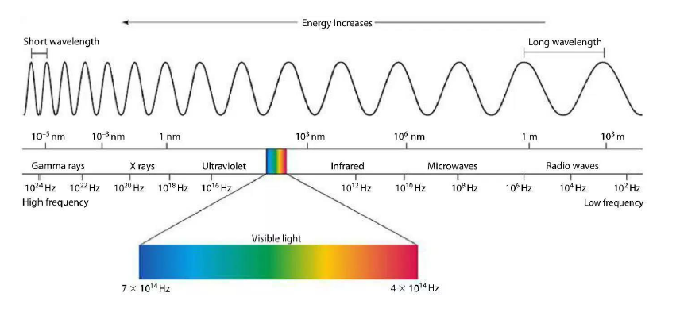

When the Sun's radiation reaches the sea surface, the shortwave radiation is attenuated by the water, and the intensity of light decreases exponentially with water depth. The intensity of light at depth can be calculated using the [**Beer-Lambert Law**](https://en.wikipedia.org/wiki/Beer-Lambert_Law)**.**

The Beer Lambert law is combined of two laws and each are correlates which state that, the **absorbance** of light is **proportional** to **the thickness of the sample** or absorbance is proportional to the **concentration of the sample**.

**The higher frequency corresponds to the higher attenuation in the wireless domain this is the reason why high frequency waves cannot travel long distance because the noise from the environment becomes dominant in this case.**

Rayleigh scattering refers to the scattering of light off the molecules of the air. It increases with the fourth power of the frequency and is more effective at short wavelengths.

I= amount of light scattered

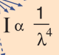

The size of a scattering particle is often parameterized by the ratio



where *r* is the particle's radius, *λ* is the [wavelength](https://en.wikipedia.org/wiki/Wavelength) of the light and *x* is a dimensionless parameter that characterizes the particle's interaction with the incident radiation such that:

**Rayleigh scattering applies** to the case when the **scattering particle is very small (x ≪ 1**, with a particle size < 1 /10 wavelength[[9]](https://en.wikipedia.org/wiki/Rayleigh_scattering#cite_note-9)) and the whole surface re-radiates with the same phase.

THE MORE THE FREQUENCY, MANY OSCILLATIONS PER SECOND. SO, THE AMOUNT OF ENERGY REMOVED DURING HIGH PRESSURE STATE IS ALSO HIGH PER SECOND.

Generally, Shortwave generally extends from 3–30 MHz

**Line-of-sight propagation:** <https://en.wikipedia.org/wiki/Line-of-sight_propagation>

 Electromagnetic [transmission](https://en.wikipedia.org/wiki/Transmission_(telecommunications)) includes light emissions traveling in a [straight line](https://en.wikipedia.org/wiki/Straight_line). The rays or waves may be [diffracted](https://en.wikipedia.org/wiki/Diffraction), [refracted](https://en.wikipedia.org/wiki/Atmospheric_refraction), reflected, or absorbed by the atmosphere but obstructions with material and generally cannot travel over the [horizon](https://en.wikipedia.org/wiki/Horizon) or behind obstacles.

In contrast to line-of-sight propagation (opposite to line-of-sight propagation), at [low frequency](https://en.wikipedia.org/wiki/Low_frequency) (below approximately 3 [MHz](https://en.wikipedia.org/wiki/Hertz)) **DUE TO**[**DIFFRACTION**](https://en.wikipedia.org/wiki/Diffraction), [radio waves](https://en.wikipedia.org/wiki/Radio_wave) can travel as [ground waves](https://en.wikipedia.org/wiki/Ground_wave) (20KHz-50MHz), which follow the contour of the Earth. This enables [AM radio](https://en.wikipedia.org/wiki/AM_radio) stations to transmit beyond the horizon. Additionally, frequencies in the [shortwave](https://en.wikipedia.org/wiki/Shortwave) bands between approximately 1 and 30 MHz, can be reflected back to Earth by the [ionosphere](https://en.wikipedia.org/wiki/Ionosphere), called [skywave](https://en.wikipedia.org/wiki/Skywave) or "skip" propagation, thus giving radio transmissions in this range a potentially global reach.

However, at frequencies above 30 MHz ([VHF](https://en.wikipedia.org/wiki/VHF) and higher) and in lower levels of the atmosphere, neither of these effects (**DIFFRACTION AND RELECTION BY REFRACTION ON ION-SHPERE)** are significant. Thus, any obstruction between the transmitting antenna ([transmitter](https://en.wikipedia.org/wiki/Transmitter)) and the receiving antenna ([receiver](https://en.wikipedia.org/wiki/Receiver_(radio))) will block the signal, just like the [light](https://en.wikipedia.org/wiki/Light) that the eye may sense. Therefore, since the ability to visually see a transmitting antenna (disregarding the limitations of the eye's resolution) roughly corresponds to the ability to receive a radio signal from it, the propagation characteristic at these frequencies is called "line-of-sight". The farthest possible point of propagation is referred to as the "radio horizon".

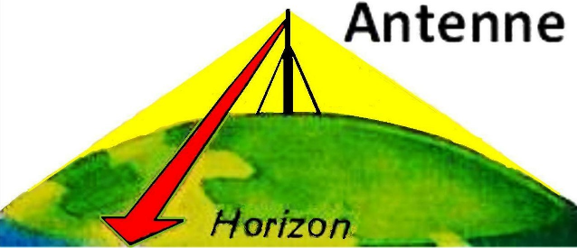

Line of sight propagation to an antenna

Line of sight transmission is used to medium range radio transmission such as [cell phones](https://en.wikipedia.org/wiki/Cell_phone), [cordless phones](https://en.wikipedia.org/wiki/Cordless_phone), [walkie-talkies](https://en.wikipedia.org/wiki/Walkie-talkie), [wireless networks](https://en.wikipedia.org/wiki/Wireless_network), [FM radio](https://en.wikipedia.org/wiki/FM_radio) and [television broadcasting](https://en.wikipedia.org/wiki/Television_broadcasting) and [radar](https://en.wikipedia.org/wiki/Radar), and [satellite communication](https://en.wikipedia.org/wiki/Satellite_communication), such as [satellite television](https://en.wikipedia.org/wiki/Satellite_television). Line-of-sight transmission on the surface of the Earth is limited to the distance to the visual horizon, which depends on the height of transmitting and receiving antennas. It is the only propagation method possible at [microwave](https://en.wikipedia.org/wiki/Microwave) frequencies and above. At microwave frequencies, moisture in the atmosphere ([rain fade](https://en.wikipedia.org/wiki/Rain_fade)) can degrade transmission.

**Non-Directional Beacon (NDB):**

**Non-Directional Beacon** is a ground-based, low frequency radio transmitter used as an instrument approach for airports and offshore (abroad) platforms.  
   
The NDB transmits an omni-directional signal that is received by the ADF or Automatic Direction Finder, a standard instrument onboard aircraft. **The pilot uses the ADF to determine the direction to the NDB relative to the aircraft.** **To navigate using the ADF, the pilot enters the frequency of the NDB and the compass card (or arrow) on the ADF will indicate the heading to the station.** The signal is transmitted on an uninterrupted 24/7 basis.  An audible Morse Code call sign of one or more letters or numbers is used to identify the NDB being received.

NDB’s used for aviation are standardized by ICAO, the International Civil Aviation Organization, Annex 10 which specifies that NDB be operated on a frequency between 190 to 1800 kHz.  In North America, the frequency range is typically from 190 to 625 kHz, for offshore operations in the North Sea 500 to 1250  kHz and for offshore Brazil, 1500 to 1800 kHz is used.  
   
The main components of an NDB ground station are the Beacon transmitter, Antenna Tuning Unit and Antenna.  
   
Typically NDBs have output power from 25 to 125 watts for reception up to approx. 100 NM. **Higher power systems from 500 to 1000 Watts are used for longer range** **applications**.  **Range depends** on a number of factors such as **output power**, **antenna**, **ground conductivity**, **frequency**, **site conditions (rainy, sunny)**, latitude, and **the condition of the ADF receiver.**  
**Non-Directional Beacon Applications**  
   
NDBs are highly reliable, typically provide decades of uninterrupted service, and are extremely low cost to install and operate.  Because of this, NDBs are the most widely used navaid in the world.  
   
In addition to serving as stand-alone primary instrument approaches at airports, **NDBs are also used as Locator Outer Markers (LOM) for Instrument landing Systems (ILS).**  **Outer Markers designate the starting area of an ILs approach or flight path to follow for a standard terminal arrival or STAR procedure.** (i.e. indicate from which point we should descend for landing).  
   
Offshore NDBs were first introduced in the early 1960’s during early years of petroleum exploration in the Gulf of Mexico.  Since that time, NDBs have become standard equipment **on offshore platforms and drill ships to provide highly reliable navigation for helicopter pilots (location of ships to be landed)** and ADF-equipped crew boats as they support crews on drilling and production platforms.

**Amplitude Modulation (AM) and FM:**

AM works by modulating or superimposing the amplitude of the signal to be sent to the carrier signal resulting in the change in amplitude of carrier signal accordingly, but frequency of carrier wave being constant called Amplitude Modulation. Change of amplitude occurs in the carrier wave. Have a larger range.

FM works by superimposing the modulating signal to the carrier signal resulting in the change of the frequency of the carrier signal accordingly, but amplitude of carrier wave being constant called Frequency Modulation. Change of frequency occurs in the carrier wave.

Frequency Translation/mixing/conversion/Heterodyning:

It is generally required to translate or shift the **modulated signal frequency** to a new band of frequency, before it’s demodulation or signal processing in the communication system (amplification, filtering, etc.).

The received signal is translated to a fixed intermediate frequency (IF) and now this IF signal can be easily “Amplified”, “Filtered” and “Demodulated”.

E.g. In most commercial AM radio receivers, the received radio frequency (RF) signal is 560-1640 KHz. But this modulated signal is shifted to an intermediate frequency (IF) to 455 KHz band for the purpose of processing.

The device which is used to perform the operation of frequency translation of the modulated wave is known as the **frequency mixer.** And this process is called frequency mixing or heterodyning.

Thus idea of the superheterodyne receiver is to reduce the high frequency radio components of the incoming carrier to a fairly low, fixed value such as to be processed at the different stages of the receiver, and also to provide good stability, gain and proper selectivity and fidelity.

**Heterodyning** is a [signal processing](https://en.wikipedia.org/wiki/Signal_processing) technique that creates new [frequencies](https://en.wikipedia.org/wiki/Frequency) by combining or mixing two frequencies. Heterodyning is used to shift one [frequency range](https://en.wikipedia.org/wiki/Frequency_range) into another, new one, and is also involved in the processes of [modulation](https://en.wikipedia.org/wiki/Modulation) and [demodulation](https://en.wikipedia.org/wiki/Demodulation). The two frequencies are combined in a [nonlinear](https://en.wikipedia.org/wiki/Linear_circuit) signal-processing device such as a [vacuum tube](https://en.wikipedia.org/wiki/Vacuum_tube), [transistor](https://en.wikipedia.org/wiki/Transistor), or [diode](https://en.wikipedia.org/wiki/Diode), usually called a [***mixer***](https://en.wikipedia.org/wiki/Frequency_mixer). In the most common application, two signals at frequencies *f*1 and *f*2 are mixed, creating two new signals, one at the sum *f*1 + *f*2 of the two frequencies, and the other at the difference *f*1 − *f*2. **These frequencies are called *heterodynes***. **Typically only one of the new frequencies is desired, and the other signal is**[**filtered**](https://en.wikipedia.org/wiki/Filter_(signal_processing))**out of the output of the mixer.** Heterodyne frequencies are related to the phenomenon of "[beats](https://en.wikipedia.org/wiki/Beat_(acoustics))" in acoustics.

**Dipole Antenna:**

 The length of the total wire, which is being used as a dipole, equals half of the wavelength (i.e., l = λ/2). Such an antenna is called as **half-wave dipole antenna**.

The name 'di-pole' indicates that the dipole antenna consists of two poles or items – two conductive elements normally on the same axis and this dipole antenna is normally split in the centre.

Current flows in these two conductive elements and the current and the associated voltage causes an electromagnetic wave or radio signal to be radiated outwards from the antenna. Normally the receiver or transmitter is connected to the dipole antenna via an intermediate **feeder** which enables the power to be transferred from one point to another.

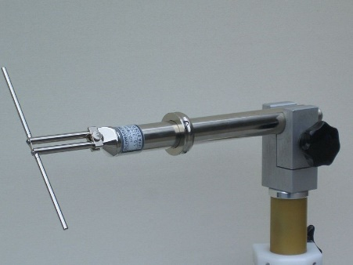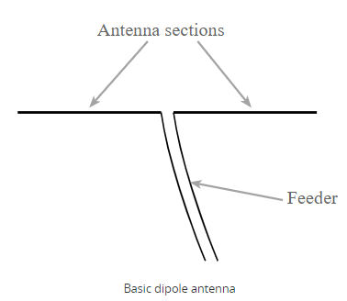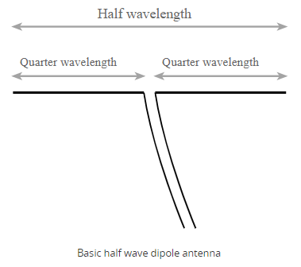

### Frequency range

The range of frequency in which half-wave dipole operates is around 3KHz to 300GHz. This is mostly used in radio receivers.

Voltage is maximum at the ends and 0 at the middle and current is minimum at ends and max at the centre.

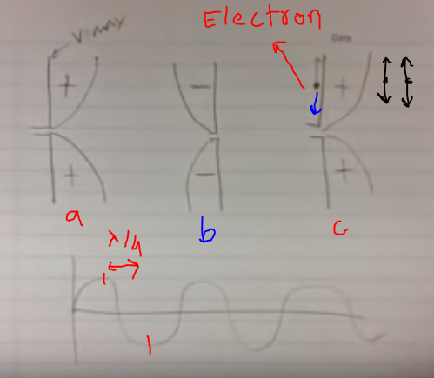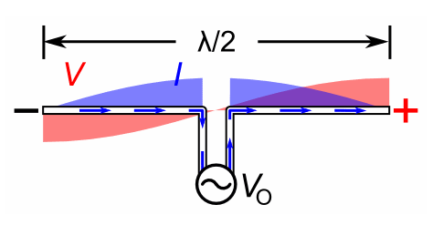

Consider a electron at the middle of the quarter length antenna, during the positive cycle the +ve voltage is maximum at the upper end and electron tries to move there. But during negative cycle, the electron tries to move away from the negative potential upper end (max negative). So, during positive and negative cycle the charge is moving up and down and so on. So , due to the movement of charge magnetic field is produced in circular like making the antenna rotational axis and electric field induced is along horizontal like parallel to the length of antenna.

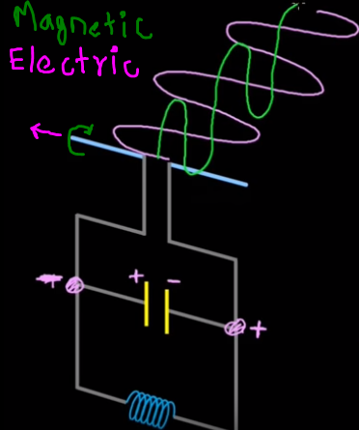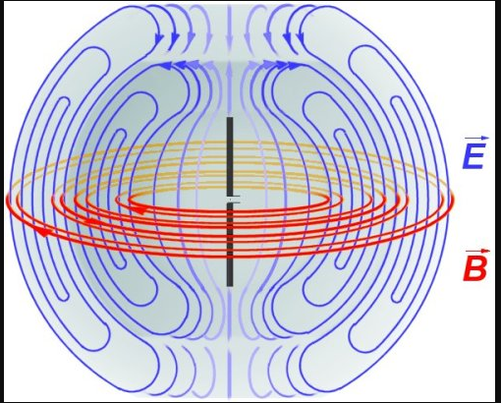

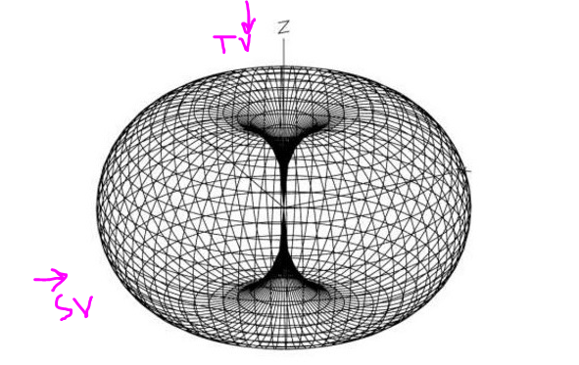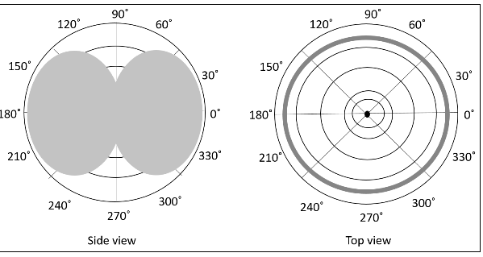

<https://www.tutorialspoint.com/antenna_theory/antenna_theory_radiation_pattern.htm>

Advantages:

* The two-pole design enables the device to receive signals from a variety of frequencies.
* The biggest advantage of a dipole antenna is its simplicity. Dipole gap sizes have almost no impact on the practical performance of the antenna.

### Disadvantages

The following are the disadvantages of half-wave dipole antenna −

* Not much effective due to single element.so work better only with a combination.
* The outdoor antenna are large and wide. For very low frequencies, the wavelength is too long to make a dipole antenna practical unless you use a quarter-wave dipole.
* This type of antenna are not used for space communication.

### Applications

* Used in radio receivers.
* Used in television receivers (like in old one tv, tow wires extend from tv)

**Short Dipole Antenna**

Perhaps the simplest of all antennas is the Short Dipole Antenna. It is a special case of the Dipole antenna. In its simplest form, it is basically an open circuit wire with the signal being fed at the centre. The term “short” in short dipole antenna doesn’t directly refer to its size but rather to the size of the wire relative to the wavelength of the signal.

[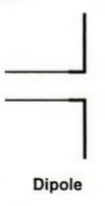](https://www.electronicshub.org/wp-content/uploads/2019/03/Types-of-Antennas-Dipole-Antenna.jpg)

For a typical Short Dipole Antenna, the length of the wire les less than the tenth of the wavelength of the frequency of operation.

**L<λ/10**

**Loop Antenna**

A Loop antenna is formed by a single or multiple turn of wire forming a loop. The radiation produced by loop antenna is comparable to a short dipole antenna.

[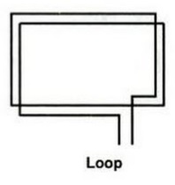](https://www.electronicshub.org/wp-content/uploads/2019/03/Types-of-Antennas-Loop-Antenna.jpg)

**Horn Antenna**

One of the most popular antennas is the Horn Antenna, which effects the transition between transmission line and wave propagating in free space. It acts as a natural extension to a waveguide.

[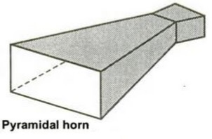](https://www.electronicshub.org/wp-content/uploads/2019/03/Types-of-Antennas-Horn-Antenna.jpg)

**Monopole (Marconi) Antenna**

A **monopole antenna** is a class of [radio antenna](https://en.wikipedia.org/wiki/Antenna_(radio)) consisting of a straight [rod](https://en.wikipedia.org/wiki/Rod_(geometry))-shaped conductor, often mounted perpendicularly over some type of [conductive](https://en.wikipedia.org/wiki/Electrical_conductor) surface, called a [ground plane](https://en.wikipedia.org/wiki/Ground_plane)

A monopole antenna is half of a simple dipole antenna located over a grounded plane as shown in the figure below.

[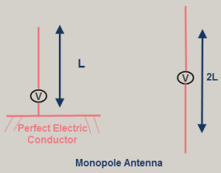](https://www.elprocus.com/wp-content/uploads/2014/07/monopole-antenna.jpg)The radiation pattern above the grounded plane will be same as the half wave dipole antenna, however, the total power radiated is half that of a dipole; the field gets radiated only in the upper hemisphere region. The directivity of these antennas become double compared to the dipole antennas.

The monopole antennas are also used as vehicle mounted antennas as they provide the required ground plane for the antennas mounted above the earth.

**Folded dipole antenna**

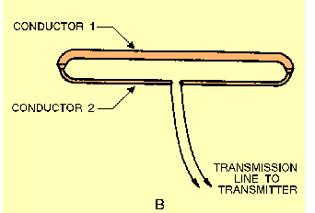

A FOLDED DIPOLE is an ordinary half-wave [antenna](http://electriciantraining.tpub.com/14182/css/Chapter-4-Antennas-167.htm) that has one or more additional conductors connected across its ends. Additional conductors are mounted parallel to the dipole elements at a distance equal to a very small fraction of a [wavelength](http://electriciantraining.tpub.com/14184/css/Wavelength-20.htm).

The tips of the antenna are folded back until they almost meet at the feedpoint, such that the antenna comprises one entire wavelength. The main advantage of this arrangement is an improved bandwidth over a standard half-wave dipole.

**Reflector and director antennae:**

<http://www.ph.surrey.ac.uk/satellites/main/assets/schoolzone/project1/reflectors_directors.htm>

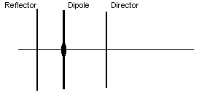

The single or folded dipole is of limited gain and is not very directional. To increase the gain, "parasitic" elements can be added. Unlike the active dipole, these are made from single length of narrower gauge aluminum and do not need insulating from the tubular aluminum antenna boom.

**Reflectors:**A reflector is a "parasitic" element because it is not electrically connected to the dipole or downlead/feeder; it is a length of conductor, usually aluminum, of length around 5% longer than the dipole, mounted behind the dipole.

**Directors:** Further increases in gain and directionality can be achieved if an additional parasitic element or "director" is added, 5% shorter than the dipole and the 0.1 to 0.15 wavelengths in front of it.

**CHAPTER 7**

**Bleed air:**

**Bleed air** is **fresh, clean, hot air** taken from the compressor section of the engine **before** it is mixed with fuel or exhaust gasses. Common uses for hot bleed air are wing and engine ice protection, cabin pressurization, engine starter motors, and air driven hydraulic pumps.

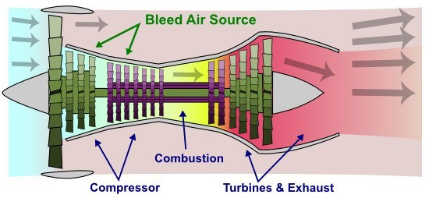

**Cabin pressurization** is a process in which conditioned air is pumped into the [cabin](https://en.wikipedia.org/wiki/Aircraft_cabin) of an aircraft or [spacecraft](https://en.wikipedia.org/wiki/Spacecraft), in order to create a safe and comfortable environment for passengers and crew flying at high altitudes. For aircraft, this air is usually [bled off](https://en.wikipedia.org/wiki/Bleed_air) from the [gas turbine engines](https://en.wikipedia.org/wiki/Gas_turbine) at the compressor stage, and for spacecraft, it is carried in high-pressure, often [cryogenic](https://en.wikipedia.org/wiki/Liquid_oxygen) tanks. The air is cooled, humidified, and mixed with recirculated air if necessary, before it is distributed to the cabin by one or more [environmental control systems](https://en.wikipedia.org/wiki/Environmental_control_system_(aircraft)).[[1]](https://en.wikipedia.org/wiki/Cabin_pressurization#cite_note-1) The cabin pressure is regulated by the outflow valve.

A manual mode allows us to adjust the position of the outflow valve should both auto systems fail. Pressurization systems work great and rarely cause any trouble.

### Where does pressurized air come from?

* **Electric Compressors**  
  Old piston powered airliners, like the Boeing Stratocruiser, used electric air compressors to pump fresh, outside air into the cabin. This system worked well, but the compressors added a lot of weight to the aircraft.
* **Turbo-compressors**  
  Early jetliners, like the Douglas DC-8 and Boeing 707 used bleed air from the engines to spin turbo-compressors. The turbo-compressors then pumped fresh outside air into the cabin.
* **Engine Bleed Air**Most modern airliners use bleed air from the compressor section of the engines to pressurize the cabin. This very hot air must be cooled to a comfortable temperature before it’s directed into the cabin.
* **Electric Compressors (Again!)**  
  The new Boeing 787 Dreamliner brings back the electric compressor. The 787’s electrical system powers compressors, just like on the old Stratocruiser. Advances in technology make this system far more efficient than it’s predecessor from the 1950’s.

**QFE** is the barometric **altimeter setting** that causes an **altimeter** to read zero when at the reference datum of a particular airfield (in practice, the reference datum is either an airfield center or a runway threshold).

When sitting on the ground at an airport, dialing QNH into the altimeter will cause it to display the airport’s altitude above sea level.

Manual setting knob which is geared to the pointer and use to reset the pointer position manually.

**Total air temperature:**

In aviation, [stagnation temperature](https://en.wikipedia.org/wiki/Stagnation_temperature) is known as **total air temperature** and is measured by a temperature probe mounted on the surface of the aircraft. The probe is designed to bring the air to rest relative to the aircraft. As the air is brought to rest, [kinetic energy](https://en.wikipedia.org/wiki/Kinetic_energy) is converted to [internal energy](https://en.wikipedia.org/wiki/Internal_energy). The air pressure increased and is compressed and experiences an [adiabatic](https://en.wikipedia.org/wiki/Adiabatic_process) increase in temperature. Therefore, total air temperature is higher than the static (or ambient) air temperature.

Total air temperature is an essential input to an [air data computer](https://en.wikipedia.org/wiki/Air_data_computer) in order to enable computation of static air temperature and hence [true airspeed](https://en.wikipedia.org/wiki/True_airspeed).

AOA sensor:

The angle-of-attack sensor indirectly measures the amount of lift generated by the wings. The name refers to the angle between the wing and oncoming air. Its main purpose is to warn pilots when the plane could aerodynamically stall from too little lift, leading to a loss of control.

Many of the sensors include a small vane attached to the outside of a commercial aircraft. Most planes have two or three vanes as part of a redundant system. But they are not complicated machines. The Wright brothers used a version on their first flight.

While EASA recognizes that two vanes are “the bare minimum requirement to meet the safety objectives

Placing too much trust in the sensors can cause trouble. One of the most serious crashes tied to angle-of-attack sensors occurred in 2008, when XL Airways Germany Flight 888T hit the Mediterranean Sea, killing seven people. French authorities blamed water-soaked angle-of-attack sensors on the Airbus 320, saying they generated inaccurate readings and set up a chain of events that resulted in a stall.

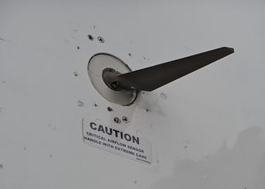

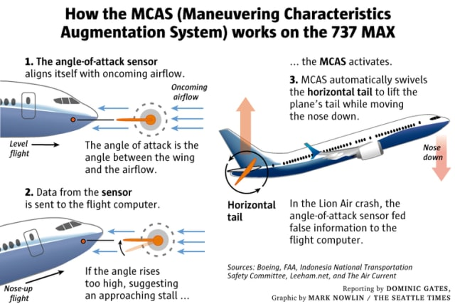

Unlike pitot probes, the angle-of-attack sensors — which are mounted in singles, doubles, or triples in every transport jet you fly today — are vanes, not tubes. They align with the airflow as the aircraft gathers speed.

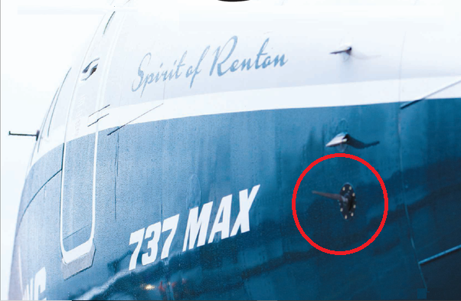

▲*Here is an angle of attack sensor on the MAX, just below the pitot tube, which should be giving sleepless nights to Dennis Muilenberg*.

CHAPTER 8

**Terrain Following radar (TFR) OR Terrain Following:**

**Terrain-following radar** (TFR) is a military [aerospace](https://en.wikipedia.org/wiki/Aerospace) technology that allows a very-low-flying [aircraft](https://en.wikipedia.org/wiki/Aircraft) to automatically maintain a relatively constant altitude above ground level and therefore make detection by enemy radar more difficult. It is sometimes referred-to as *ground hugging* or *terrain hugging* flight.

The system works by transmitting a [radar](https://en.wikipedia.org/wiki/Radar) signal towards the ground area in front of the aircraft. The radar returns can then be processed to see how the terrain ahead varies, and then used by the aircraft's flight computers to calculate flight-path changes in order to maintain a reasonably constant height above the earth. The computer will consider many factors in determining the flight path for the aircraft, such as distance to the forward terrain, aircraft speed and velocity, angle of attack and quality of signal being returned.

### Advantages and Disadvantages[[edit](https://en.wikipedia.org/w/index.php?title=Terrain-following_radar&action=edit&section=3)]

Terrain following radar is primarily used by military strike aircraft, to enable flight at very low altitudes (sometimes below 100 feet/30 metres) and high speeds. **Since radar detection by enemy radars and interception by**[**anti-aircraft**](https://en.wikipedia.org/wiki/Anti-aircraft)**systems require a line of sight to the target**, flying low to the ground and at high speed reduces the time that an aircraft is vulnerable to detection to a minimum by hiding the aircraft behind terrain as far as possible. This is known as [terrain masking](https://en.wikipedia.org/wiki/Terrain_mask).

**Threshold Marking:**

The Threshold is the first part of a runway that is available for landing — technically the actual edge (end) of the runway where the landing area begins. The threshold is usually indicated by runway edge markings (or a *threshold bar* on runways with a displaced threshold) and threshold markings (often called “piano keys”). All instrument runways have threshold markings, and even some visual runways have them. For visual runways, the threshold can be considered to be “marked” by the runway numbers.

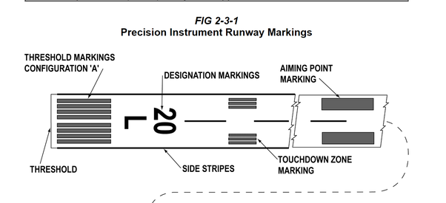

**Azimuth**: Angle from the line joining ‘geographical north and center of earth’ to line joining ‘object location and center of earth’.

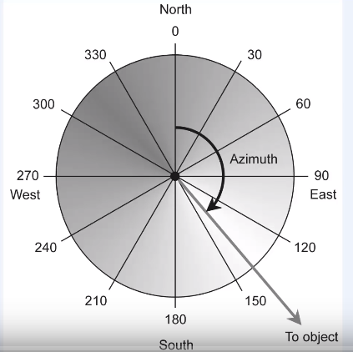

**Instrument Landing System:**

It is still the most used approach and landing aid that is used regularly by airliners. ILS provides means of carrying out a precision instrument approach to a runway giving guidance both in the horizontal plane, azimuth and in the vertical plane (the glide slope).

ILS provides the pilot with visual instruction in the cockpit to enable him to fly the aircraft down a predetermined glide slope and extended runway centerline (the localizer) to his decision height or decision altitude.

At decision height the pilot decides to land if he has the required visual references but if he doesn’t he goes around and follows the published missed approach procedure.

There are three parts to the ground installation:

* 1. Localizer antenna:

This transmit in the VHF band and is located on the extended centerline of the runway at the upwind end. It’s signal provides the extended centerline, from localizer to the approach side of runway.

* 1. Glide Slope Antenna:

This transmit in UHF range and it’s frequency paired with the localizer. **It is located about 120 meters away from centerline and some 300 meters upwind of the threshold markings and being the touchdown or landing point.** It consists two rectangular transmitters mounted on a mast (tall upright pole or structure) approximately 10 m tall. It provides a descent plane at a predetermined angle to the horizontal. Normally 3 degrees according to ICAO. When combine with the localizer this provides a precise path to fly to the **touchdown point.**

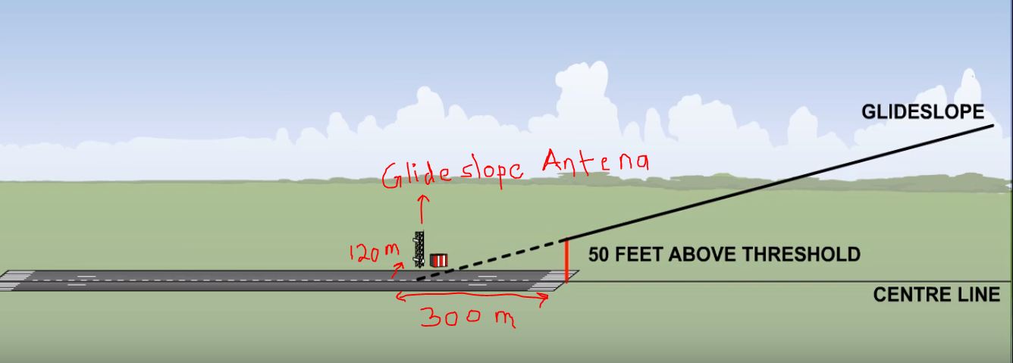

* 1. Marker beacons:

There are two or three marker beacons on the approach side of the runway. They are designed to give the pilot a cross check of height against range, as he crosses over them during his approach.

The distance is shown on the approach plate from the **touch down point.** Each beacon triggers a different colored light and audio signal in the cockpit as the aircraft passes over.

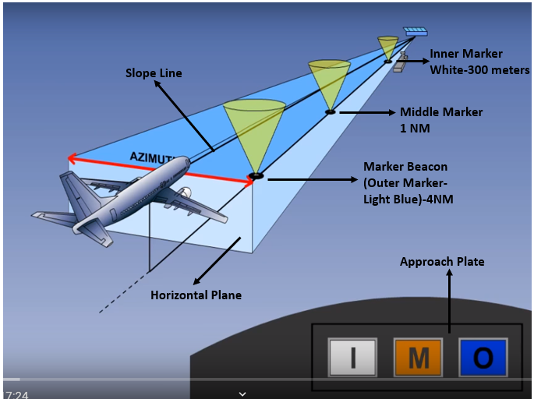

A **standalone** device is any mechanism or **system** that can perform its function without the need of another device, computer, or connection.

**Avionics System Integration:**

World War 2 (WW2 1939-1945) resulted in a major growth in the electronic equipment installed in aircraft and the birth of avionics, with the very rapid development of airborne radar systems and associated displays, radar warning systems and ECM, and more advanced autopilot systems exploiting electronics. Installation of the electronic equipment (or ‘black boxes’). In general, however, the systems were ‘stand-alone’ systems and their integration into an overall system was carried out by specific crew members such as the navigator, bomb aimer or radar operator.

The 1950s period saw the emergence of a number of avionic sub-systems. The first major step towards integrating avionic systems was taken in the mid1950s with the establishment of the ‘weapon system’ concept. These concepts were incorporated in the 1960s generation of aircraft, some of which are still in service

EXAMPLE FOR THE WEAPON AIMING INTEGRATED SYSTEM IN ALL WETHER

As an example of the overall system approach, consider the requirements for a naval strike aircraft. The aircraft must be able to operate from an aircraft carrier in all weathers and be able to find the target and attack it with a suitable weapon (or weapons) with a high probability of success. Operational analysis shows that to minimise the probability of detection and alerting the enemy’s defences, the aircraft needs to approach the target at high subsonic speeds (550–600 knots) at very low level at a height of 100 ft or so above the sea so as to stay below the radar horizon of the target as long as possible. The avionic sub-system specifications can then be determined from the overall system requirements with an aircraft crew comprising pilot and observer/navigator. Hence in the above example, the avionic equipment fit would comprise:

• Radar – target acquisition in all weather conditions.

• Doppler – accurate ((4 knots) velocity sensor for DR navigation. (Note: IN systems capable of accurate initial alignment at sea on a moving carrier were still under development in the early 1960s.)

• Attitude heading reference system (or master reference gyro system – UK terminology) – attitude and heading information for pilot’s displays, navigation computer, weapon aiming computer, autopilot.

• Air data computer – height, calibrated airspeed, true airspeed, Mach number information for pilot’s displays, weapon aiming, reversionary DR navigation, autopilot.

• Radio altimeter – very low level flight profile during attack phase and all weather operation. • Navigation computer – essential for mission.

• Autopilot – essential for reduction of pilot work load.

• Weapon aiming computer – essential for mission.

• HUD – all the advantages of the HUD plus weapon aiming for low level attack; for example, ‘toss’ bombing.

• Stores management system – control and release of the weapons.

• Electronic warfare (EW) systems – radar warning receivers, radar jamming equipment. Essential for survivability in hostile environment.

**ALL SUBSYSTEM WERE INTEGRATED TO FINALIZE A SYSTEM HAVING THE CAPACITY FOR AN AIRCRAFT CARRIER IN ALL WEATHERS AND BE ABLE TO FIND THE TARGET AND ATTACK IT WITH A SUITABLE WEAPON (OR WEAPONS) WITH A HIGH PROBABILITY OF SUCCESS.**